Module EE565  
Medical Imaging and Visualization Assignment #2  
3D Rendering Technique

Stephen Holland

Student id: 13210385

Part 1

Update the maximum intensity projection program so that it implements transparent voxel rendering using ?



1. Call method getSliceAsBufferedImage() from MaximumIntensityProjection().

Which will return a Buffered image.

**public** **class** MaximumIntensityProjection **extends** JFrame{

**public** MaximumIntensityProjection() {

Volume volume = **new** Volume("Stanford-CT_Head.vol");

BufferedImage bufferedImage = volume.getSliceAsBufferedImage();

JFrame frame = **new** JFrame();

frame.setLayout(**new** BorderLayout());

JLabel label = **new** JLabel(**new** ImageIcon(bufferedImage));

frame.add(label);

frame.pack();

frame.setDefaultCloseOperation(JFrame.*EXIT_ON_CLOSE*);

frame.setVisible(**true**);

}

**public** **static** **void** main(String args[]) {

**new** MaximumIntensityProjection();

}

}

1. Inside getSliceAsBufferedImage() get the the following image “stannford-CT_Head.vol” data:

**int** volumeWidth = volume.getWidth(); // Width

**int** volumeHeight = volume.getHeight(); //Height

**int** volumeDepth = volume.getDepth(); //Depth

Range range = getRange();

**int** min = range.getMinimum(); // Minimum Voxel color = 0

**int** max = range.getMaximum(); //Maximum Voxel color = 3272

**int** diff = max - min; //Difference 3272

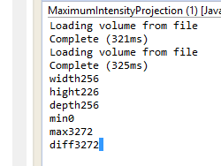

// create a buffered image with this data

BufferedImage image = **new** BufferedImage(volumeWidth, volumeHeight, BufferedImage.*TYPE_INT_ARGB*);

// initialize variables

**float** C_out = 0.0f; // initialize to black (0.0)

// Enter the volume rendering loop

**for**(**int** x=0; x<volumeWidth; x++){

**for**(**int** y=0; y<volumeHeight; y++){

C_in = 0.0f; // initialize to 0.0 the color coming into the voxel that is furthest from the view plane is black (0.0)

**for** (**int** z=0; z<volumeDepth; z++) // Render from front of head to back

**// for**(**int** z=volumeDepth-1; z>=0; z--) // come from Back of head furthest from plane. This process starts at the voxel that is furthest from the view plane

{

**int** voxel = getVoxel(x, y, z);

**int** grey = ((voxel - min) * 255) /diff //C value

**float** alpha = grey/255.0f; //255.0 (white);

C_out = C_in*(1.0f - alpha) + grey*alpha; // ray casting formula e.g. -> Cin = 0,C = 255,alpha = 0.8.

C_in = C_out; // C_in is now the value of C_out going through the loop

}

**int** grey = (**int**)C_out; //cast to int for pixel formula

**int** pixel = 0xff000000 | (grey << 16) | (grey << 8) | grey;

image.setRGB(x,volumeHeight-1-y, pixel); // use volumeHeight-1 else upside down

}

}

**return** image;

}

Output:

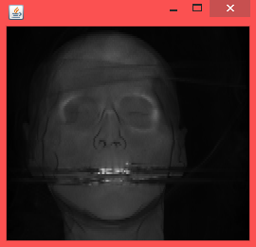

Part 2

Generate transparent voxel renderings of the patient’s head from the left, right and back

To generate different views then set the Z depth for loop as follows:

Back Head View:

**for**(**int** z=volumeDepth-1; z>=0; z--) // come from Back of head furthest from plane. This process starts at the voxel that is furthest from the view plane

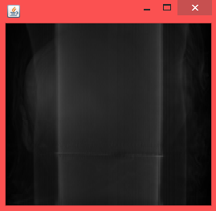

Rightside Head View:

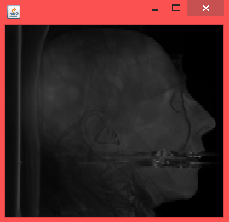

**int** voxel = getVoxel(z, y, x); // Change around axis for side view

Part 3:

For the front view only, generate transparent voxel renderings where the value for

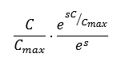

and s is varied from 1 to 8 in steps of 1?

The **java.lang.Math.exp(float a)**returns Euler's number e raised to the power of a float value. This method returns the value es, where *e* is the base of the natural logarithms.

So first get the es

Set up a variable so can change value s.

S = 0.0;

Next get es -> Euler's number = (float)Math.*exp*(S);

Calculation to get new alpha value:

alpha = (**float**) (alpha * Math.*exp*(s*alpha)/eulersNum);

then just put in value from 1-8 into S variable.

Here are the following results with the corresponding s value;

S = 8.oof: S= 1.00f:

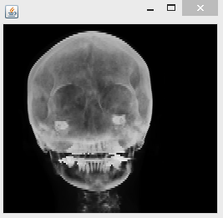

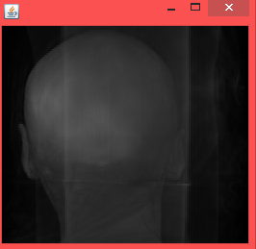

CODE for Question 3:

// initialize variables

**float** C_out = 0.0f;

**float** s = 7.00f; //adjust as needed

**float** eulersNum = (**float**)Math.*exp*(s);

// Enter the volume rendering loop

**for**(**int** x=0; x<volumeWidth; x++)

**for**(**int** y=0; y<volumeHeight; y++){

**float** C_in = 0.0f;

// for(int z=0; z<volumeDepth; z++) //view from front

**for**(**int** z=volumeDepth-1; z>=0; z--) // come from Back of head furtest from plane

{

**int** voxel = getVoxel(x, y, z);

**int** grey = ((voxel - min) * 255);

**float** alpha = grey/255.0f;

alpha = (**float**) (alpha * Math.*exp*(s*alpha)/eulersNum); //Question 3

C_out = C_in*(1.0f - alpha) + grey*alpha;

C_in = C_out;

}

**int** grey = (**int**)C_out;

**int** pixel = 0xff000000 | (grey << 16) | (grey << 8) | grey;

image.setRGB(x,volumeHeight-y-1, pixel);

}

Keywords: [Click here to add keywords.]

Module EE565  
Medical Imaging and Visualization Assignment #2  
3D Rendering Technique

[The body of your paper uses a half-inch first line indent and is double-spaced. APA style provides for up to five heading levels, shown in the paragraphs that follow. Note that the word Introduction should not be used as an initial heading, as it’s assumed that your paper begins with an introduction.]

# [Heading 1]

[The first two heading levels get their own paragraph, as shown here. Headings 3, 4, and 5 are run-in headings used at the beginning of the paragraph.]

## [Heading 2]1

[To add a table of contents (TOC), apply the appropriate heading style to just the heading text at the start of a paragraph and it will show up in your TOC. To do this, select the text for your heading. Then, on the Home tab, in the Styles gallery, click the style you need.]

[Heading 3]. [Include a period at the end of a run-in heading. Note that you can include consecutive paragraphs with their own headings, where appropriate.]

[Heading 4]. [When using headings, don’t skip levels. If you need a heading 3, 4, or 5 with no text following it before the next heading, just add a period at the end of the heading and then start a new paragraph for the subheading and its text.] (Last Name, Year)

[Heading 5]. [Like all sections of your paper, references start on their own page. The references page that follows is created using the Citations & Bibliography feature, available on the References tab. This feature includes a style option that formats your references for APA 6th Edition. You can also use this feature to add in-text citations that are linked to your source, such as those shown at the end of this paragraph and the preceding paragraph. To customize a citation, right-click it and then click Edit Citation.] (Last Name, Year)

References

Last Name, F. M. (Year). Article Title. *Journal Title*, Pages From - To.

Last Name, F. M. (Year). *Book Title.* City Name: Publisher Name.

Footnotes

1[Add footnotes, if any, on their own page following references. For APA formatting requirements, it’s easy to just type your own footnote references and notes. To format a footnote reference, select the number and then, on the Home tab, in the Styles gallery, click Footnote Reference. The body of a footnote, such as this example, uses the Normal text style. (Note: If you delete this sample footnote, don’t forget to delete its in-text reference as well. That’s at the end of the sample Heading 2 paragraph on the first page of body content in this template.)]

Tables

Table 1

[Table Title]

|  |  |  |  |  |
| --- | --- | --- | --- | --- |
| Column Head | Column Head | Column Head | Column Head | Column Head |
| Row Head | 123 | 123 | 123 | 123 |
| Row Head | 456 | 456 | 456 | 456 |
| Row Head | 789 | 789 | 789 | 789 |
| Row Head | 123 | 123 | 123 | 123 |
| Row Head | 456 | 456 | 456 | 456 |
| Row Head | 789 | 789 | 789 | 789 |

Note: [Place all tables for your paper in a tables section, following references (and, if applicable, footnotes). Start a new page for each table, include a table number and table title for each, as shown on this page. All explanatory text appears in a table note that follows the table, such as this one. Use the Table/Figure style, available on the Home tab, in the Styles gallery, to get the spacing between table and note. Tables in APA format can use single or 1.5 line spacing. Include a heading for every row and column, even if the content seems obvious. A default table style has been setup for this template that fits APA guidelines. To insert a table, on the Insert tab, click Table.]

Figures

Figure 1. [Include all figures in their own section, following references (and footnotes and tables, if applicable). Include a numbered caption for each figure. Use the Table/Figure style for easy spacing between figure and caption.]

For more information about all elements of APA formatting, please consult the APA Style Manual, 6th Edition.